a)
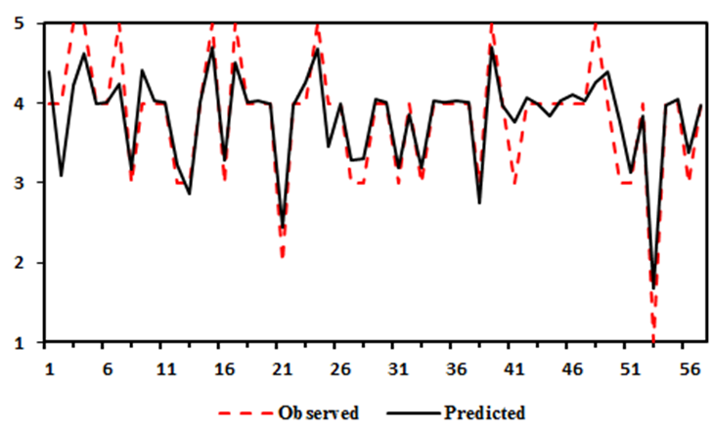
b)
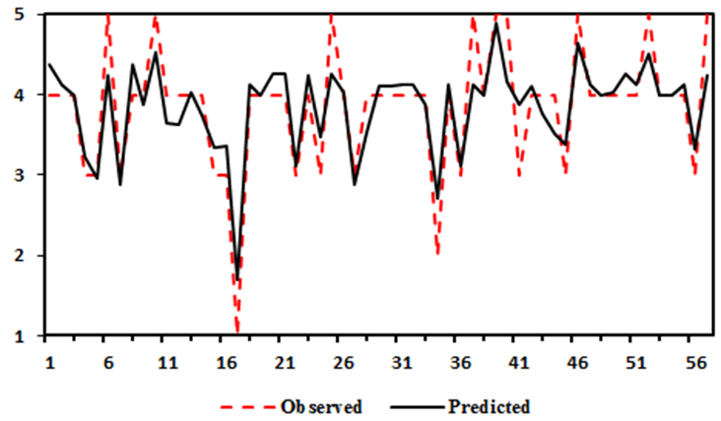

Figure 1: Satisfaction prediction values obtained using a) Random Forest and b) K-nearest neighborhood models along with the observed values

a)
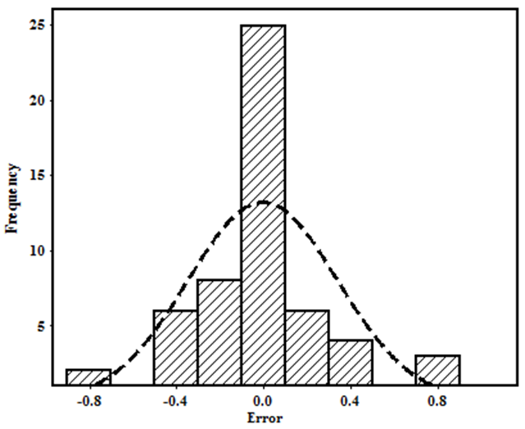
b)
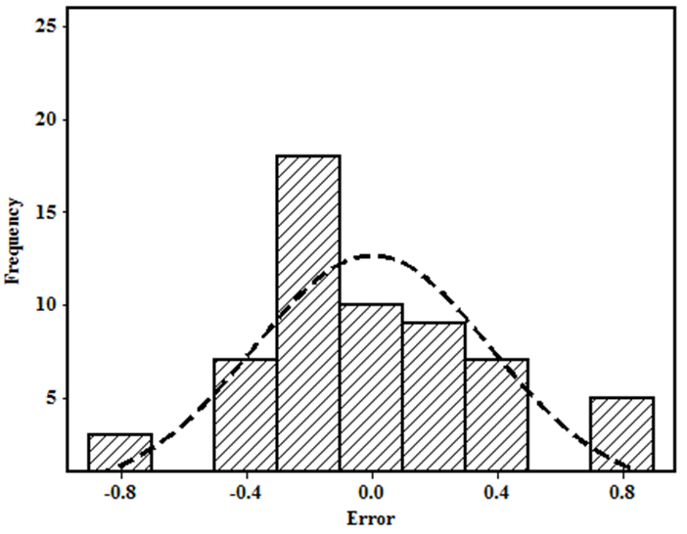

Figure 2: The skewness of the predicted values of the response variable obtained by the a) Random Forest and b) K-nearest neighborhood models.

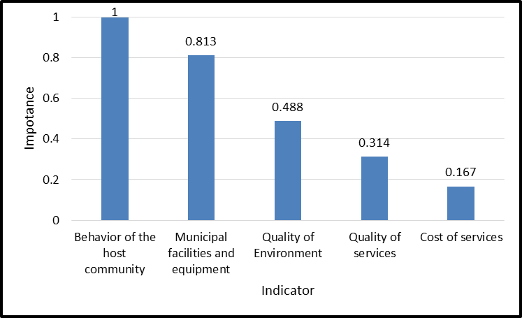

Figure 3: Variable importance of the variables affecting tourism satisfaction

